Jackson Hot Air Jubilee
July 18-20, 2025
* * * * * * * * *
Emergency Response Plan



Hot Air Jubilee
Emergency Response Plan

Table of Contents

INTRODUCTION 3
GENERAL 3
EMERGENCY SERVICES BRIEFINGS 3
EVENT SCHEDULE 4
NOTIFICATION FLOW CHART 5
COMMAND PROCEDURES 6
INCIDENT COMMANDER 6
EMERGENCY MEDICAL SERVICES (EMS) BRANCH 7
LAW ENFORCEMENT BRANCH 7
COMMUNICATIONS / LOGISTICS BRANCH 8
EMERGENCY ROLE OF HOT AIR JUBILEE BALLOON FESTIVAL STAFF 8
MASS CASUALTY INCIDENT PLAN 9
MASS CASUALTY EVACUATIONS 9
MASS CASUALTY – SPECTATOR/CROWD EVACUATION 10 SEVERE WEATHER PLAN/EVACUATION 10
NATIONAL WEATHER SERVICE WEATHER DEFINITIONS 11
FIRE PROTECTION EVACUATION 11
TRANSFER/PASS OF COMMAND 11
MEDIA INFORMATION 12 MEDIA STATEMENT 12
EVENT MAP 13 SPECIAL HAZARDS – PROPANE 14 EMERGENCY CONTACTS 15
HOT AIR JUBILEE COMMITTEE MEMBERS 16

Introduction
The Hot Air Jubilee brings in hot air balloon enthusiasts, as well as spectators, from all over the region. The main attractions are the 20-25 balloons, which lift off in the early morning and early evening, and the Night Glow on Friday and Saturday evenings. There are other family friendly events taking place throughout the weekend such as a kid’s activities, crafts & vendors, food vendors and car show. This plan has been developed to address the special concerns that the balloons may present, as well as provide for the welfare of the participants and spectators of this event utilizing the National Incident Management System.
GENERAL
The Goal of Emergency Services
- Provide the public, pilots and participants the highest level of safety and emergency response possible.
- Provide the highest level of fire protection possible.
- Provide spectators a high level of emergency first aid and/or medical attention and transport to a higher level of care as needed.
- Provide appropriate Command/Control of an incident or accident.

Area Agencies & Emergency Services

Emergency 9-1-1
Hot Air Jubilee Command Center (Balloonmeister) (517) 414-5795
HAJ Safety Officer- Darrin Fall (517) 416-5199
Jackson Police Department (Sergeant on Duty) (517) 768-8704
Jackson Fire Department (517) 788-4150
Jackson County Emergency Mgmt Program Manager (517) 768-7946
Jackson Community Ambulance/EMS (517) 787-5700

EMERGENCY SERVICES BRIEFINGS

- Safety Personnel Meeting and Overall Emergency Services Briefing
Prior to the event a letter will be mailed or delivered to all emergency service entities. This is to inform them of the event and goal of the organizers to be ready for possible emergencies, advise them to the races, familiarize personnel with the field layout, and identify final logistical needs for emergency services. Opportunity for them to make adjustments to schedules for personnel and advise the Event Organizers of any special restrictions they may have.

- Pilots Daily Briefing
Each morning the Pilot Balloonmeister or his designee is responsible for conducting a pilot pre-flight briefing (see Pilot Handbook for further details), pilot roll call will be taken. Messages using the Remind App regarding the “go” or “no go” status of scheduled launches will be disseminated to the pilots at the preflight briefings or via their personal mobile phones. Also, emergency messages, such as “land ASAP”, will be disseminated via the mobile phones.

- End of Event “Wrap Up” Briefing – (Sunday after the conclusion of the event)
This briefing will include the Balloonmeister and teams, which will include or invited to attend: launch/target personnel, safety/emergency service personnel, and a representative from propane/refueling area if applicable to address the issues encountered over the event period to improve safety for the next year’s event.

EVENT SCHEDULE
Thursday  07/20/2023 | Friday  07/21/2023 | Saturday  07/22/2023 | Sunday  07/23/2023
1 p.m.  Set up at the Field | 6:30 – 9:30 a.m.Fly Over Jackson - Possible independent launches | 6:30 – 9:30 a.m.  Competition Flight #1 | 6:30 – 9:30 a.m.  Competition Flight #3
6:30 - 8:30 p.m.  Media Flight | 6:30 – 9:00 p.m.  Sponsor’s Flight  9:30 – 10:30 p.m.  Night Glow | 6:30 – 9:00 p.m.  Competition Flight #2  9:30 – 10:30 p.m.  Night Glow | Flight TBD
Refueling at 3113 Lansing Avenue., Jackson,MI | Refueling at 3113 Lansing Avenue., Jackson,MI | Refueling at 3113 Lansing Avenue., Jackson,MII | Refueling at 3113 Lansing Avenue., Jackson,MI

NOTIFICATION FLOW CHART

Unified Command
Hot Air Jubilee: Steven Sitko & Jacque Austin
Jackson Fire Deputy Director: David Wooden
Jackson Police Lieutenant: Jason Ganzhorn
Jackson Ambulance Chief: TBD

Public Information Officer (Hot Air Jubilee)
Safety Officer: TBD
Liaison Officers
Superintendent of Ella Sharp Park
Eric Terrian 517-990-2267

Deputy Unified Command
Hot Air Jubilee OIC
Jackson Fire Department OIC
Jackson Police Department OIC
Jackson Ambulance OIC

Fire & Rescue
Operations
517-788-4150

EMS Operations
517-787-5700
Supervisor on Duty

Law Enforcement
Operations
Jackson Police
Sergeant on Duty
517-768-8704

Hot Air Jubilee
Jacque Austin 517-414-7890

Fire Suppression
Supervisor

Other Fire
Operations

Triage
Supervisor

Treatment
Supervisor

Transportation
Supervisor

Air Medical

Grounds/Sites
Jacque Austin

Concessions & Vendors
Jacque Austin

Public Address
Announcer
Andy Merritt

Refueling
Darrin Fall

Air Support

Traffic Flow
Jackson Police

Criminal
Investigation

Scene Security

Fire Suppression
Supervisor

Volunteers & Parking
Jacque Austin

COMMAND PROCEDURES
All agencies likely to respond to an incident must establish procedures relative to the Incident Command System (ICS). These procedures should describe in detail the process of establishing command and developing command organization.
Command procedures are designed to fix the responsibility of command on one specific individual through a standardized identification system, depending on the arrival sequence of responders.
Command procedures should ensure that a strong, direct and visible command will be established from the onset of the incident. Command procedures establish an effective incident management organization defining the activities and responsibilities assigned to the IC and other individuals operating within the ICS.
Such procedures provide a system to process and communicate information to support incident management, planning and decision-making.

INCIDENT COMMANDER

The IC is the single person responsible for all emergency services at the event. Additionally, in the event of a large scale accident or mass casualty incident the IC will become the overall Incident Commander (IC) for the accident and/or event, or will assign an IC as deemed necessary.

Hot Lines
The IC will have direct communications to the following members of the Balloon event safety team. Cell phones will be used to talk directly with:
- The HAJ Balloonmeister
- HAJ Safety Officer
- HAJ Announcer
If cell phones are not working during an emergency situation, radios will be used sparingly.

Spotters
All members of the Hot Air Jubilee Balloon Committee will act as spotters during the event. Any safety concern will be reported directly to the Safety Officer or Balloonmeister.

- Keeping track of balloons participating in competition.
- Provide messenger services from Command Center to onsite teams.

EMERGENCY MEDICAL SERVICES (EMS) BRANCH
Emergency Medical Services
The EMS response will be dispatched by the Jackson Police Department office in case of an emergency and dispatch medical support when advised.
Medical Resources
Medical resources are used to provide medical services to the participants and spectators of the Hot Air Jubilee. Additional duties may include coordination of a single resource i.e., Henry Ford Health hospital, ambulances, Care flight helicopter, to assist in transporting patients to a trauma center. This can be done by way of direct radio contact with Jackson Police Dispatch.

Ambulance
Ambulance will be available and dispatched immediately and in accordance with situational requirements.

LAW ENFORCMENT BRANCH
Agencies that make up the Law Enforcement Branch
Lt. Jason Ganzhorn Jackson Police Department (517) 768-8771
Jackson Police Department (Sergeant on Duty) (517) 768-8704
Other Mutual Aid Departments as requested by Jackson Police Department

Duties and Responsibilities:
The above-mentioned agencies will be notified and be participants in safety briefing and invited to be on scene when they feel it is needed. They will not be expected to maintain a presence during the entire event.

Law Enforcement Response to Aircraft Emergencies On-Site Accidents:
Responders shall comply with instructions from the on scene ESD/IC to protect the scene of an incident until proper authorities are on-site. If local law enforcement agencies are on scene, they will be primary control of law enforcement.
In the event of a serious on-site aircraft emergency / mishap within the Launch Field or other controlled area, the following law enforcement response will occur:
- The first law enforcement officer on the scene will assume control of the law enforcement response and will coordinate the support of all Hot Air Jubilee volunteers as needed.
- The Law Enforcement Branch Director will consult with the IC regarding the need for offsite resources and will make the request directly to dispatch.
- HAJ Staff will help prevent spectators, crews, and other non-essential personnel from responding to the aircraft emergency/mishap site when available.
- Ingress traffic will be strictly monitored to ensure that only essential personnel are permitted access to the aircraft emergency/mishap site.
- On-scene law enforcement officers will make every attempt to aid crew members, families and friends of an aircraft emergency/mishap victim as the situation warrants, but the equipment, by law, should not be disturbed in any way. It has to remain in place until inspected by either Federal Aviation Administration (FAA) or National Transportation Safety Board (NTSB) representatives before it is moved.
- No law enforcement or security officer shall respond to an aircraft emergency/mishap site unless specifically directed by the IC.
- Notification to FAA - Further notification of the FAA IIC will be made as expeditiously as possible.

Off-Site or Accidents Outside of the Controlled Areas
Emergency response of law enforcement personnel and HAJ staff will respond to an off-site accident for support when directed by the IC. Notification of the FAA will be in accordance with line #7 above.

COMMUNICATIONS / LOGISTICS BRANCH

Cell Phones
The Hot Air Jubilee Safety Officer and Balloonmeister will be the main point of contacts for any Emergency Services. This is to provide a single point of request for an emergency response and eliminate the need for numerous calls to 911 or dispatch. The Safety Director or Balloonmeister will turn over command of the situation to the IC as requested to coordinate all emergency service activity at the accident or incident as necessary.

Cell phones have become a very common and useful means of communication with the Emergency Services at the Hot Air Jubilee. Cell phone numbers for the HAJ Staff select Emergency Services and Consumers Energy will be provided to all pilots.

EMERGENCY ROLE OF HOT AIR JUBILEE STAFF

In the event of an accident resulting in serious injury or death to any pilot or balloon festival participant the staff will report immediately to the IC when they have finished any Life Safety activity.

In the event of a mass casualty incident, the Staff will respond to the Incident Commander and direct HAJ resources, pilots and crews to assist with the incident and give reliable reports and updates to the Incident Commander. HAJ Board Chair or Vice Chair staff member may be assigned the Public Information Officer (PIO) role at the IC’s discretion for the incident and a briefing room and scheduled briefing times as soon as practical.

CROWD CONTROL-Launch Fields
Crowd control will be the responsibility of the Safety Officer assisted by HAJ staff and volunteers in the launch field. All HAJ officials will be wearing hi-visibility event shirts and crowd control volunteers will be wearing safety vests for easy identification. The crowd will not be allowed on the launch field. The PA system will be used to update the crowd in any emergency and given instructions for safe evacuation.

CROWD CONTROL-Target areas
Spectators will not be allowed within 1000 foot of the target. Balloon crews will be allowed to enter up to 200 feet of the target area. If requested by the pilot the chase crew will be allowed to enter the 200 foot perimeter of the target but the pilot score will be zero. The scoring and measuring officials will be responsible for crowd control, if needed, within 200 feet of the target area and will maintain the 1000 foot perimeter of the target. Score keepers and volunteers will address the crowd and advise of emergency situations.
MASS CASUALTY INCIDENT PLAN

All balloon events have the potential for a multi-casualty incident. The Jackson Police Department are organized to very quickly and effectively handle a multi-casualty incident by the pre-positioning of resources and being organized to directly follow the established Jackson County Multi-Casualty Incident Plan. In the event of a multi-casualty incident at the command structure and emergency resources are already in place to immediately start managing the incident. The IC will be the first person to respond to the incident of Fire, EMS, and Law enforcement.

Additional Fire, EMS, and Law Enforcement resources may be requested as needed through a formal process with all parties involved notified and a specific time given.

Many systems, procedures and safety features are in place to prevent a multi-casualty incident at the Hot Air Jubilee. However, if an unfortunate incident occurs, there is a plan for trained personnel and resources to effectively handle it.

MASS CASUALTY EVACUATIONS

The HAJ Mass Casualty Evacuation Plan will utilize the following Traffic Control Points 4th Street and Hickory, Elmdale and Birchwood and the Maplewood and Probert exits from Ella Sharp Park. These Traffic Control Points will be staffed by Jackson Police Department Friday and Saturday evenings and in the case of emergency situations. These provide the best rapid response routes unless otherwise determined by circumstances of the incident. Such evacuation routes would then be determined by medical and/or law enforcement agencies involved. Other evacuation options could utilize, depending upon severity of medical conditions, helicopter airlift.

MASS CASUALTY – SPECTATOR/CROWD EVACUATION

Crowd evacuations in the event of an on-field mass casualty incident would be determined based upon the particular circumstances using the safest routes available. Such routes would include any and all of the vehicle and/or pedestrian walking paths into or out of the park complex.

Any and all non-essential response personnel and event volunteers will be utilized to provide direction, guidance and assistance to evacuees if necessary.

Traffic control will be provided for the parking area.

Additional assistance will be provided through verbal announcements from the event announcer’s stage area on a routine basis.

SEVERE WEATHER PLAN/EVACUATION

Weather will be tracked throughout the event. In most cases the public will be advised of the impending weather and asked to vacate the premises.
If severe weather is approaching that has potential to be dangerous to people on the ground, there is not enough protected space at the park for the size crowds that are expected. As a result the recommended procedure will be to evacuate the park if the pending storm looks to be extremely severe. If this needs to occur, the following will take place:
- Jackson Police Department will position officers at the entrances and at nearby major intersections to facilitate traffic flow out of the park
- The public address system and patrol cars with loud speakers will be used to advise the crowd to leave the park in an orderly manner.
- Parking volunteers will be alerted to the evacuation so they can stop any more cars from entering into the park.
- If the weather gets bad suddenly and unexpectedly people will be advised to take shelter in their cars or in the Ella Sharp Museum.

NATIONAL WEATHER SERVICE WEATHER DEFINITIONS

A severe thunderstorm must contain hail that is three-quarter inch in diameter or larger or straight-line winds of 58 mph or stranger and/or a tornado. The National Weather Service issues severe thunderstorm and tornado watches and warnings for severe thunderstorms.

A severe thunderstorm watch means conditions are favorable for severe thunderstorms containing hail that is three-quarters of an inch in diameter or larger and/or straight line winds of 58 mph or stronger in the area.

A tornado watch means conditions are favorable for severe thunderstorms containing hail that is three-quarters of an inch in diameter or larger and/or straight line winds of 58 mph or stronger and/or possible tornadoes in your area.

A severe thunderstorm warning means a severe thunderstorms containing hail that is three-quarters of an inch in diameter or larger and/or straight line winds of 58 mph or stronger has been detected by radar or reported by storm spotters in the area.

A tornado warning means a tornado has been detected by radar or reported by storm spotters in the area. The severe storm may also contain hail that is three-quarters of an inch in diameter or larger and/or straight line winds of 58 mph or stronger.

FIRE PROTECTION EVACUATION

Should a rapidly expanding grass fire occur, evacuation and entry points will be immediately identified for purposes of re-routing participants, personnel and traffic accordingly. All necessary emergency responders will be contacted and dispatched for fire suppression purposes.

TRANSFER/PASS OF COMMAND

Command of an incident is transferred to improve the quality of the Command organization. The probability of an exchange of command is likely to occur.

The fact that a “higher ranking” person may have arrived on the scene does not necessarily mean that he/she is prepared to assume Command of the incident as they may not have adequate knowledge of the situation or how to execute the provisions of the Emergency Response Plan.

The preferred method of transferring Command is through a face-to-face meeting between the initial IC and the subsequent IC. During such an exchange it is critical that a comprehensive briefing take place. Such a briefing should include, at a minimum, the following information:

- Present incident status/conditions (rescue situations, injuries, hazards, etc.)
- The strategies and tactics being employed.
- Progress toward achieving incident objectives.
- Safety considerations and concern’s and conduct personnel accountability roll call.
- Assignment/deployment of resources being used.
- Projection of incident conditions i.e. escalating or diminishing and resource needs and availability.

It is generally recommended, in an effort to preserve continuity that changes in Command be held to a minimum, and therefore should be passed only one time, and only if deemed beneficial and necessary, and then only under extraordinary circumstances to protect the integrity of the incident.

MEDIA INFORMATION

All requests for information, interviews, and media footage shall be referred to and/or must be approved by the Hot Air Jubilee Committee or IC. All Emergency Service personnel shall refrain from any contact with the media. If asked for comments please refer the media to the Hot Air Jubilee Committee or IC. In the case of an accident/crash, absolutely no comments/interviews shall be given by Emergency Personnel to the media. All accident/crash information releases shall be handled by the Hot Air Jubilee Committee or IC.

MEDIA STATEMENT
Create a general statement before an incident occurs. Adapt statement during crisis.
Emphasize safety of visitors and staff first.
Briefly describe the HAJ’s plan for responding to emergency.
Issue brief statement consisting only of the facts.
Respect privacy of victim(s) and family of victims(s). Do not release names to media.
Refrain from exaggerating or sensationalizing crisis.

SPECIAL HAZARDS – PROPANE
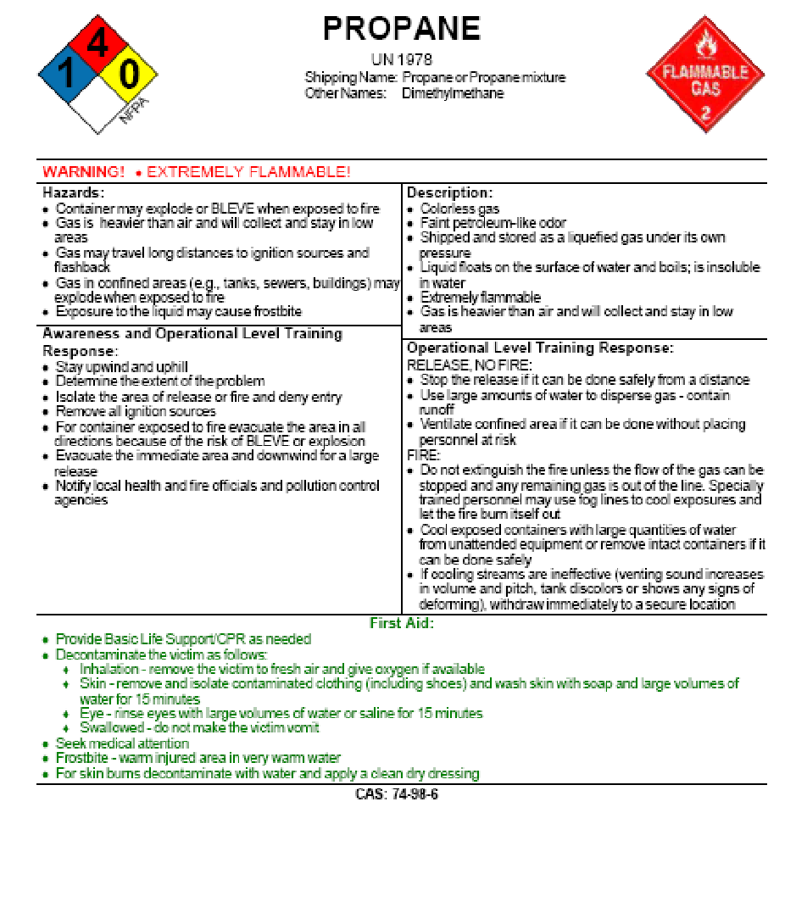
EMERGENCY CONTACTS

Balloonmeister Steven Sitko 517-414-4795 Cell
Safety Officer Darrin Fall 517-416-5199 Cell
FAA Liaison Steven Sitko 517-745-3451 Cell
Jackson Comm. Ambulance Dispatch 517-787-5700 Office
Jackson Fire Department Station OIC 517-788-4150 Office
Dave Wooden 517-788-4250 Station
Jackson Police Department Sergeant On Duty 517-768-8704 Station
Lt. Jason Ganzhorn 517-768-8771 Office
Ella Sharp Park Eric Terrian 517-990-2267 Cell
517-788-4343 Office
FAA (Detroit FSDO) TBD TBD Cell
TBD Office
Line Strike Emergency 9-1-1

